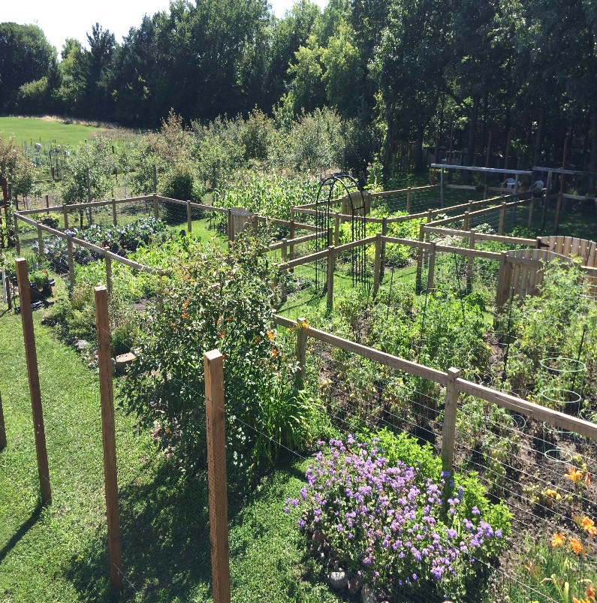

Enter in your own data and photo of yourself or one related to your talk. Save it with the title of your talk & then email and put Speakers Bureau in the Subject Line to [wimgaorg@gmail.com](mailto:wimgaorg@gmail.com)

***Include a photo if you wish.***

**Your Name: August Hoffman**

**Your Email: august.hoffman@metrostate.edu**

**Your Street Address: 598 White Oak Drive**

**City: Hudson**

**County: St. Croix**

**State: WI**

**Phone Number: (818) 205-7652**

**Distance Willing to Travel: Fairbanks, AK**

**Bold the one category that best describes your talk:**

* **Fruits, Vegetables, Herbs**
* Trees & Shrubs
* Perennials
* **Garden Design**
* Natives or Pollinators
* Garden Pests
* Other

**Talk Title: Developing Community Garden or Developing Fruit Orchards**

**Talk Description & Bio**

I can provide a 30 minute discussion addressing the development of community vegetable gardens and developing fruit tree orchards. Additionally, my background is in Community Psychology and I can provide a brief discussion addressing the importance of communities in providing opportunities for sustainable (i.e., "green") environmental projects to help individuals feel better connected to their own community. Additionally, community gardens provide a great way for newcomers to the neighborhood to get to know one another by sharing ideas relative to healthy foods.

August John Hoffman is currently a Professor of Psychology at Metropolitan State University and President of the IFO Faculty Association. He earned his B.A. from UC Santa Barbara, M.A. from Radford University in Clinical Psychology (with an emphasis in Sport Psychology), and Ph.D. from UCLA in counseling psychology. As a former professor of psychology at Compton College, CSU Northridge, and Pepperdine University, he has assisted students from various educational backgrounds in accomplishing their goals. He began and developed a highly successful gardening program at Compton College in an effort to help students improve their campus and community. Dr. Hoffman’s current research projects at Metropolitan State University include urban forestry and the development of a community fruit tree orchard and community garden at Inver Hills Community College. Current research interests also include community service work and student mentoring as effective methods to reduce ethnic conflict and improve social capital among student and community members. For the last five years Dr. Hoffman has conducted research combining outdoor gardening work with Metropolitan State University students with community members. Students generally appreciate the ability to engage in community service work and see how psychological theory applies itself within the community with community members. Additionally, Dr. Hoffman has taught several psychology courses including Evolutionary Psychology and Sport Psychology, which include an applied approach to creating healthy lifestyles for his students. 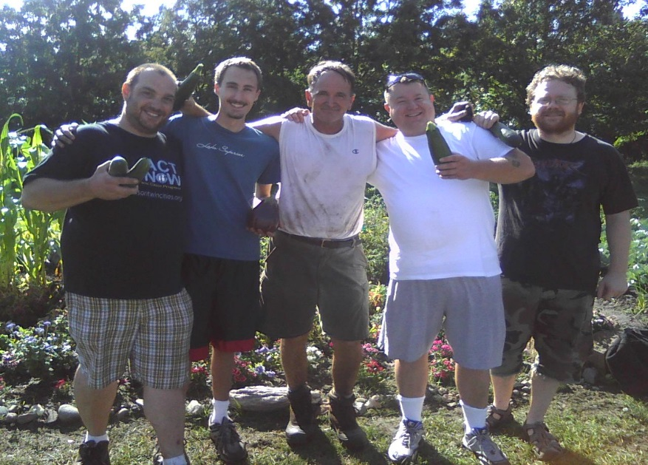He has published several books and academic research articles, including the texts, *Creating a Transformational Community*, *Philosophical Foundations of Evolutionary Psychology, Unity Through Community Service Activities*; *Understanding Sport Psychology and Human Behavior*; and, *Stop Procrastinating Now!* He enjoys gardening at his home in Hudson, Wisconsin during his time off with his family – Nancy his wife, and two children A.J. and Sara.