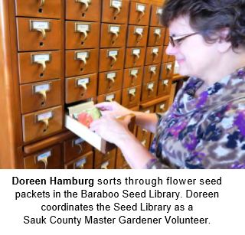
Enter in your own data and photo of yourself or one related to your talk. Save it with the title of your talk & then email and put Speakers Bureau in the Subject Line to wimgaorg@gmail.com

Your Name: Doreen Hamburg
Your Email: Doreen.Hamburg@yahoo.com
Your Street Address:
410 11th Street
City: Baraboo
County: Sauk
State: WI
Phone Number: 608-963-8755
Distance Willing to Travel: 100 miles
Bold the one category that best describes your talk:
- Fruits, Vegetables, Herbs
- Trees & Shrubs
- Perennials
- Garden Design
- Natives or Pollinators
- Garden Pests
- Other

Talk Title:

Seed Saving for the Novice

Talk Description & Bio
- Enter Brief Talk Description Here
If you are new to seed saving, this is the class for you., presented by MGV Doreen Hamburg. Learn about the history of seed saving, common seed terminology, and how to plant and save seeds for best results.

- Brief Bio Here
Doreen grew up on a dairy farm near Loganville, WI where her gardening interests were nurtured by her parents and grandparents. She has been an active Master Gardener since 2008. In 2015 she became one of the founding members of the Baraboo Seed Library.

3/1/2018 emt

