Include a photo if you wish.
Enter in your own data and photo of yourself or one related to your talk. Save it with the title of your talk & then email and put Speakers Bureau in the Subject Line to wimgaorg@gmail.com

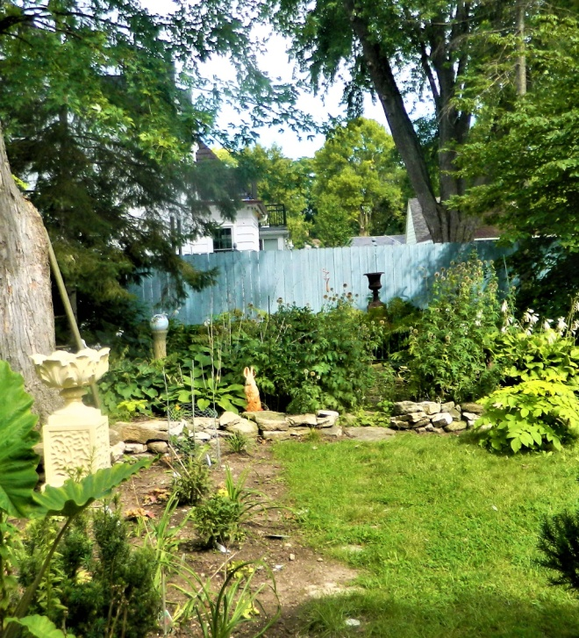
Your Name: Don Brill
Your Email: donal.brill@gmail.com
Your Street Address: 706 Lincoln St.
City: Neenah
County: Winnebago
State: WI
Phone Number: 920-470-2067
Distance Willing to Travel: WI
Bold the one category that best describes your talk:
- Fruits, Vegetables, Herbs
- Trees & Shrubs
- Perennials
- Garden Design
- Natives or Pollinators
- Garden Pests
- Other

Talk Title: Garden Design for Home Owners who want to Design their own gardens or work with a contractor. What you need before you start a garden project you will like.

Talk Description & Bio
- Enter Brief Talk Description Here
How the human eye works affects gardens like art. Create the look and your style. Small or large changes should be what you want and what fit your home front & back.
Brief Bio Here in this space including Master Gardener status )
I am a Master Gardener, at retirement I took 2 years of horticulture classes at Fox Valley Technical College including a year each of design and maintenance. I have designed gardens, with features clients chose.

3/1/2018 emt

