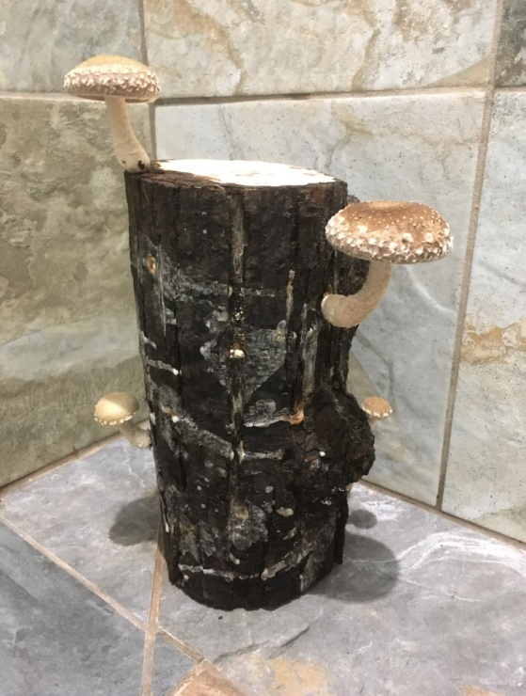
Enter in your own data and photo of yourself or one related to your talk. Save it with the title of your talk & then email and put Speakers Bureau in the Subject Line to wimgaorg@gmail.com

Your Name: Dora Wood
Your Email: homeoasisfarm@gmail.com
Your Street Address: 11293 County Highway X
City: Chippewa Falls
County: Chippewa
State: Wisconsin
Phone Number: 715-828-3856
homeoasisfarm.com
Distance Willing to Travel: most anywhere
Bold the one category that best describes your talk:
- Fruits, Vegetables, Herbs
- Other

Talk Title: Mushroom Growing 101

Talk Description:
I began growing Wine Cap mushrooms after purchasing some at an organic farm conference. I like eating mushrooms, so why not try growing them myself? The bug has bitten and I've continued to venture into Shiitake and Oyster mushrooms. In this talk we'll learn about "beginner" mushroom varieties along with their preferred substrates and discuss some do's and don'ts to help you along the way.
Brief Bio: Dora resides just west of Chippewa Falls along the beautiful Chippewa River on Home Oasis Farm which uses sustainable, organic farming practices. She shares her solar powered homestead farm with her husband, youngest daughter, cat, dogs, free range chickens, horses and Belted Galloway beef cattle. She enjoys gardening which is part of what lead her to become a Chippewa Valley Master Gardener. Mushrooms have now became an (addictive) addition to the shaded beds and a welcome treat to the palate.

