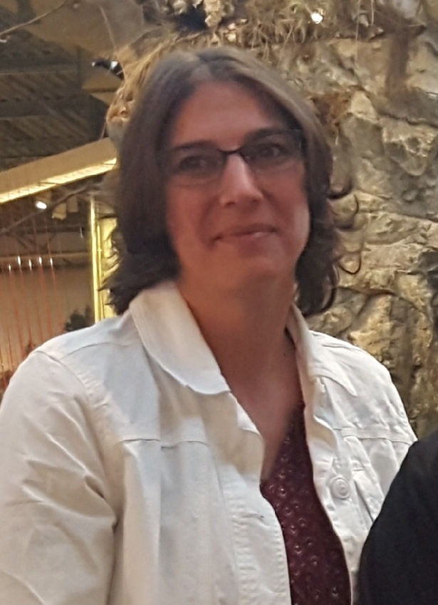
Enter in your own data and photo of yourself or one related to your talk. Save it with the title of your talk & then email and put Speakers Bureau in the Subject Line towimgaorg@gmail.com

Your Name: Dora Wood
Your Email: homeoasisfarm@gmail.com
Your Street Address: 11293 County Highway X
City: Chippewa Falls
County: Chippewa
State: WI
Phone Number: 715-828-3856
Distance Willing to Travel: most anywhere
Bold the one category that best describes your talk:
- Fruits, Vegetables, Herbs
- Trees & Shrubs
- Perennials
- Garden Design
- Natives or Pollinators
- Garden Pests
- Other

Talk Title: Edible Perennials

Talk Description & Bio
Perennials are not only beautiful and long living, but many are edible. We’ll cover some of the well known, more common edibles and introduce you to a few “not so common” ones you might be unaware of. Learn how to enjoy beauty and bounty from the same space and plants.

Brief Bio Dora resides just west of Chippewa Falls along the beautiful Chippewa River on Home Oasis Farm which uses sustainable, organic farming practices. She shares her solar powered homestead farm with her husband, youngest daughter, cat, dogs, free range chickens and Belted Galloway beef cattle. She enjoys gardening – growing numerous fruit trees, grapes, kiwi, mushrooms, various berries, a vegetable garden and some flower gardens, too which are part of what lead her to become a Chippewa Valley Master Gardener.

