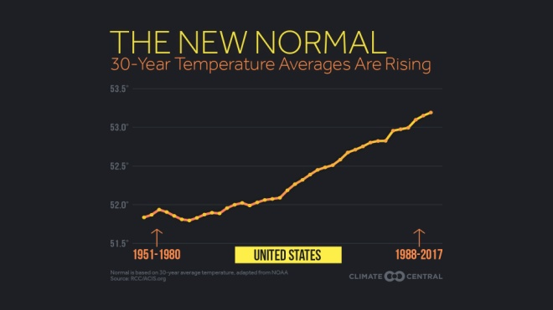
Enter in your own data and photo of yourself or one related to your talk. Save it with the title of your talk & then email and put Speakers Bureau in the Subject Line to wimgaorg@gmail.com

Include a photo if you wish.

Your Name: Bruce Krawisz, M.D.
Your Email: krawisz.bruce@marshfieldresearch.org
Your Street Address: 1600 N. Hills Drive
City: Marshfield
County: Wood
State: Wisconsin
Phone Number: 715-972-0058
Distance Willing to Travel: 300 miles
Anywhere in Wisconsin is okay.
Bold the one category that best describes your talk:
- Fruits, Vegetables, Herbs
- Trees & Shrubs
- Perennials
- Garden Design
- Natives or Pollinators
- Garden Pests
- Other

Talk Title: Climate Change and Health

Talk Description & Bio
- Human activities modify Earth’s climate and cause climate change. Greenhouse gases are added to the atmosphere. These additional greenhouse gases retain heat and cause global warming. I am a physician and I talk about the health consequences of climate change. These are: illness caused by heat exposure, spread of insect vectors of disease such ticks and mosquitoes, more powerful hurricanes, agricultural difficulties, sea level rise, and contamination of drinking water by floods and salt water. My talks are entirely scientific and medical and NOT political.
I provide information from the US National Academy of Sciences, the National Oceanic and Atmospheric administration, and the American College of Physicians.

- Brief Bio Here I am a semi-retired physician. I work part-time doing research on climate change and health. I was a pathologist at Marshfield Clinic and Prevention Genetics, both located in Marshfield, Wisconsin. I am not a master gardener.

3/1/2018 emt

