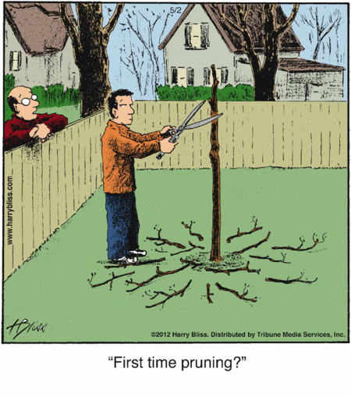
Enter in your own data and photo of yourself or one related to your talk. Save it with the title of your talk &then email and put Speakers Bureau in the Subject Line to wimgaorg@gmail.com

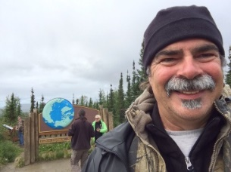
Name: Rich Fischer
Email: mrrichfischer@gmail.com
Address: 8685 Oakwood Ave
City: Neenah, WI 54956
County: Outagamie
State: Wisconsin
Phone: 920-836-1817
Distance Willing to Travel: 30 miles
Bold the one category that best describes your talk:
- Fruits, Vegetables, Herbs
- Trees & Shrubs
- Perennials
- Garden Design
- Natives or Pollinators
- Garden Pests
- Other

Talk Title:

3 Tree & Shrub Presentations:
- Tree Biology & Selections
- Tree Planting
- Tree Pruning

Talk Description & Bio
- Tree Biology & Selections: Teach you to how to select trees and shrubs for success in your landscape; the right plant for the right location. Techniques for keeping your plants healthy.
- Tree Planting: Teach you correct way to plant trees and shrubs.
- Tree Pruning: Teach you when, where, why and how to properly your prune trees and shrubs with pruning tools demonstrations.

- Brief Bio: Rich has been and Outagamie County Master Gardener Volunteer since 2001 and also earned an Associate Degree in Horticulture and Landscape Management from Fox Valley Technical College.

3/1/2018 emt

