Include a photo if you wish.
Enter in your own data and photo of yourself or one related to your talk. Save it with the title of your talk & then email and put Speakers Bureau in the Subject Line to wimgaorg@gmail.com

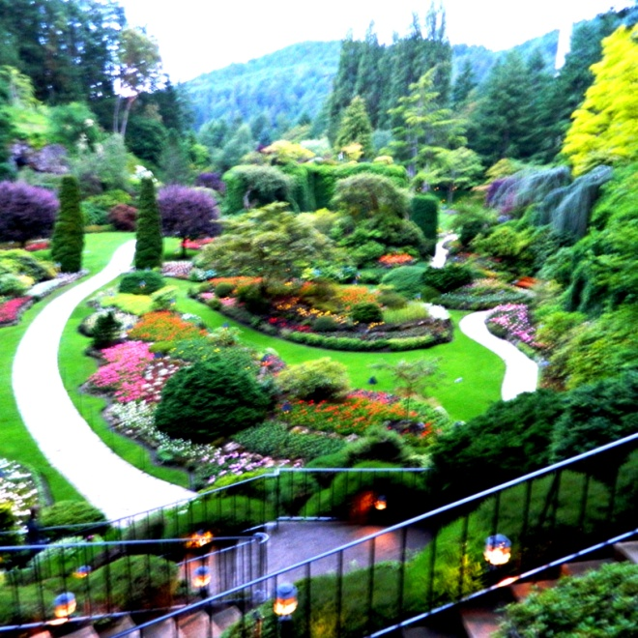
Your Name: Don Brill
Your Email: donal.brill@gmail.com
Your Street Address: 706 Lincoln St.
City: Neenah
County: Winnebago
State: WI
Phone Number: 920-470-2067
Distance Willing to Travel: WI
Bold the one category that best describes your talk:
- Fruits, Vegetables, Herbs
- Trees & Shrubs
- Perennials
- Garden Design
- Natives or Pollinators
- Garden Pests
- Other

Talk Description & Bio
- Enter Brief Talk Description Here
Gardens of Vancouver & Victoria BC, shows that climate matters. Has more top 1000 gardens anywhere else in Canada including the most visited garden in the world, the most romantic garden, best Japanese stroll garden, and others. Also you will see a garden designer’s home & gardens. You’ll use ideas to customize your garden.
Brief Bio Here in this space including Master Gardener status )
I am a Master Gardener, at retirement I took 2 years of horticulture classes at Fox Valley Technical College including a year each of design and maintenance. I have designed gardens, with features clients chose.

3/1/2018 emt

