Include a photo if you wish.
Enter in your own data and photo of yourself or one related to your talk. Save it with the title of your talk & then email and put Speakers Bureau in the Subject Line to wimgaorg@gmail.com

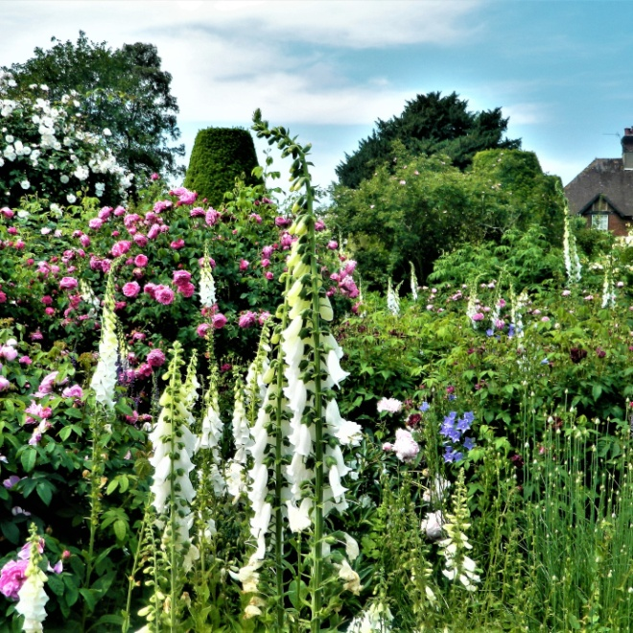
Your Name: Don Brill
Your Email: donal.brill@gmail.com
Your Street Address: 706 Lincoln St.
City: Neenah
County: Winnebago
State: WI
Phone Number: 920-470-2067
Distance Willing to Travel: WI
Bold the one category that best describes your talk:
- Fruits, Vegetables, Herbs
- Trees & Shrubs
- Perennials
- Garden Design
- Natives or Pollinators
- Garden Pests
- Other

Talk Description & Bio
English Gardens Outside London, 16 of Which are Included in the Top1000 Gardens
Enter Brief Talk Description Here
This talk is all about gardens. You can recreate the look with plants that grow here. Look at the parts and forget the size of these gardens and you see ideas you can duplicate. Look for ideas that will work for you. If you love gardens, you will be happy.

Brief Bio Here in this space including Master Gardener status)
I am a Master Gardener, at retirement I took 2 years of horticulture classes at Fox Valley Technical College including a year each of design and maintenance. I have designed gardens, with features clients chose.

3/1/2018 emt

