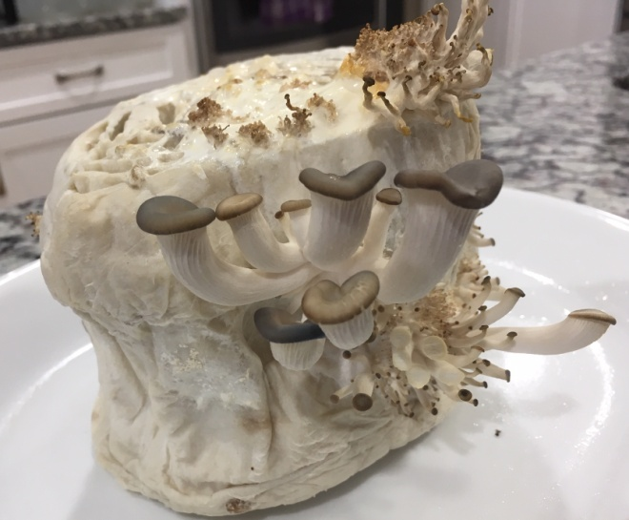
Mushroom Workshop
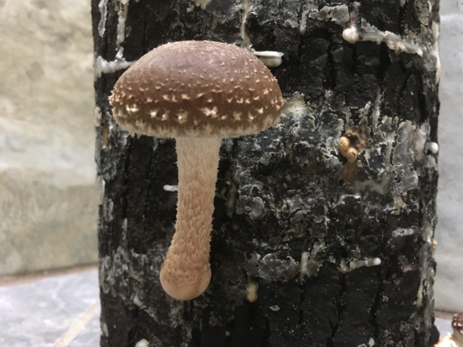
Your Name: Dora Wood
Your Email: homeoasisfarm@gmail.com
Your Street Address: 11293 County Highway X
City: Chippewa Falls
County: Chippewa
State: Wisconsin
Phone Number: 715-828-3856
homeoasisfarm.com
Distance Willing to Travel: most anywhere
Bold the one category that best describes your talk:
- Fruits, Vegetables, Herbs
- Other

Talk Title: Mushroom Workshop

Talk Description
In this interactive mushroom workshop each participant will make and take an oyster mushroom toilet paper roll and/or a 12" shiitake* inoculated log. Take home care instructions are also provided. Come, join the fun and have fresh mushrooms at your fingertips.
*Shiitake log is dependent upon log availability.

Brief Bio: Dora resides just west of Chippewa Falls on Home Oasis Farm which uses sustainable, organic farming practices. She shares her solar powered homestead farm with her husband, youngest daughter, cat, dogs, free range chickens, horses and Belted Galloway beef cattle. She enjoys gardening which is part of what lead her to become a Chippewa Valley Master Gardener. She began growing Wine Cap mushrooms after purchasing some at an organic farm conference The "shroom" bug has bitten and she has also venture into Shiitake and Oyster mushrooms. Who knows which will be next?

